# Homework: Responsive Design. Bootstrap

This document defines homework assignments from the [“Web Fundamentals (HTML & CSS)“ Course @ SoftUni](https://softuni.bg/courses/web-fundamentals/). Please submit as homework a single zip / 7z archive holding the source code of all below described problems.

## Gradient City

Create a Web page like the picture below (**100% accuracy is required**). You are given the **HTML file.** Use **SASS or LESS** to achieve the desired results. Use **mixins** for the gradients. Use variables to implement colors. Implement hover effect for the menu.

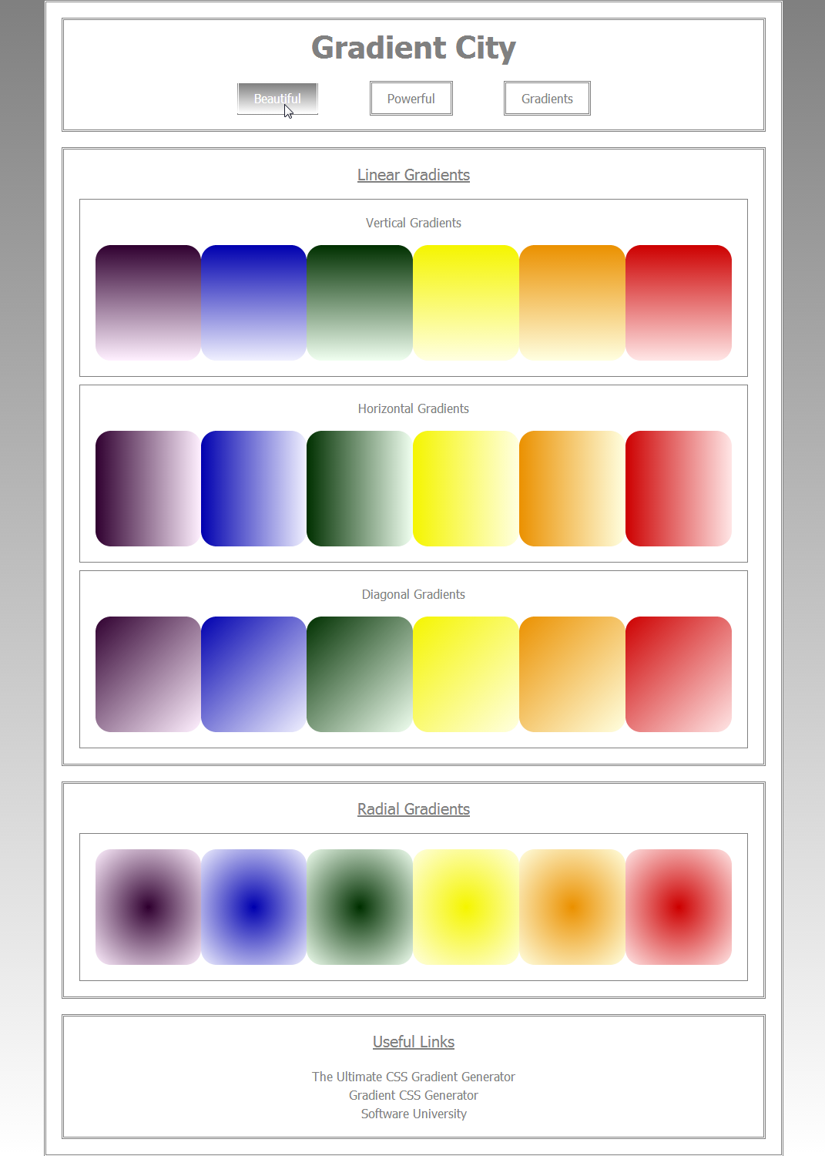

## Bootstrap Boot Camp

Create a Web page like the picture below. Make it responsive with steps by your choice. Use **BOOTSTRAP FRAMEWORK** to achieve the desired results**. Do not use the same styles**.

